# Communicating the Status of Testing

**# Source**: **Chatgpt (GPT-5-Standard) at [8/18/2025]**  
 In software testing, **communicating the status of testing** means keeping **stakeholders (managers, developers, product owners, clients, etc.) informed** about:

* How testing is progressing
* What has been completed
* What issues/defects exist
* Whether the system is ready for release

## 🔹 Definition

**# Source**: **Chatgpt (GPT-5-Standard) at [8/18/2025]**

It is the process of **reporting test progress, quality levels, risks, and outcomes** to stakeholders throughout the test life cycle.  
 This is usually done through **meetings, dashboards, and reports**.

## 🔑 Objectives

**# Source**: **Chatgpt (GPT-5-Standard) at [8/18/2025]**

1. Provide visibility into **test progress** (planned vs actual).
2. Share information about **defects** (open, closed, severity, trends).
3. Highlight **risks and blockers**.
4. Support **decision-making** (e.g., “Are we ready to release?”).
5. Ensure **transparency** and alignment across the team.

## **📂 What is Communicated?**

**# Source**: **Chatgpt (GPT-5-Standard) at [8/18/2025]**

1. **Test Progress** – % of planned tests executed, passed, failed.
2. **Defect Status** – number, severity, priority, trends.
3. **Test Coverage** – requirements, code, or risk coverage.
4. **Quality Indicators** – defect density, open defects, failure rate.
5. **Risks & Issues** – anything that may delay or impact release.
6. **Next Steps** – what testers will focus on in the upcoming cycle.

## **📝 Ways to Communicate**

**# Source**: **Chatgpt (GPT-5-Standard) at [8/18/2025]**

1. **Daily/Status Reports** – short updates on testing progress.
2. **Test Summary Reports (TSR)** – final testing outcome after test completion.
3. **Dashboards & Metrics** – real-time visual reports (charts, defect trends).
4. **Meetings/Stand-ups** – verbal updates in Agile teams (daily scrums).
5. **Defect Reports** – logged in defect tracking tools (e.g., JIRA).

### **Daily / Status Reports**

**# Source**: **Chatgpt (GPT-5-Standard) at [8/22/2025]**

* **Meaning:**
  + Written or electronic update communicating current **progress, issues, and results** of testing activities.
* **Goal:**
  + Keep **project managers, test managers, and team members informed**.
  + Highlight **risks, blockers, defects, and deviations**.
  + Support **release readiness decisions**.
* **Scope:**
  + Covers **individual tester updates** or **overall project testing progress**.
  + Includes **test execution results, defect status, and planned activities**.
* **When Used:**
  + **Daily** in Agile or iterative projects.
  + **Weekly or at milestones** in traditional projects.
* **Typical Contents:**
  + Number of **test cases planned, executed, passed, failed, blocked**.
  + **Defects logged, fixed, or pending**.
  + **Risks or issues affecting testing**.
  + **Planned testing activities for the next period**.
* **Example:**
  + 50 test cases executed → 45 passed, 5 failed
  + 3 new defects logged
  + Regression testing for login module pending
  + No blockers reported
* **Shortcut to Remember:**
  + **Daily/Status Reports = Keep everyone informed about testing progress, defects, and risks**

### Test Summary Reports (TSR)

**# Source**: **Chatgpt (GPT-5-Standard) at [8/22/2025]**

* **Meaning:**
  + A **formal document** that provides a **comprehensive summary of testing activities, results, and conclusions** at the end of a test phase or project.
* **Goal:**
  + Inform **stakeholders** about the overall quality of the system under test.
  + Support **release decisions** and highlight **risks, defects, and coverage**.
* **Scope:**
  + Covers the **entire testing phase or project**, including functional, non-functional, regression, and system testing.
  + Summarizes **test coverage, execution, defects, metrics, and deviations** from the test plan.
* **When Used:**
  + At the **end of a test phase** (e.g., system testing, UAT).
  + Before **project milestones or release decisions**.
* **Typical Contents:**
  + **Test objectives and scope**
  + **Summary of test cases executed, passed, failed, or blocked**
  + **Defect summary** (open, closed, severity, priority)
  + **Test coverage achieved**
  + **Risks, issues, and recommendations**
  + **Overall conclusion on system quality and release readiness**
* **Example:**
  + System testing executed: 200 test cases → 180 passed, 15 failed, 5 blocked
  + 12 critical defects unresolved, 5 major defects pending
  + Test coverage achieved: 95% of requirements
  + Recommendation: Release with critical defects fixed
* **Shortcut to Remember:**
  + **TSR = End-of-phase report summarizing testing results, coverage, defects, and release readiness**

### **Dashboards & Metrics**

**# Source**: **Chatgpt (GPT-5-Standard) at [8/22/2025]**

* **Meaning:**
  + **Visual representation** of testing progress, results, and key performance indicators (KPIs) using graphs, charts, and tables.
* **Goal:**
  + Provide **real-time, easy-to-understand insights** to stakeholders.
  + Highlight **trends, risks, defects, and coverage** at a glance.
  + Support **data-driven decisions** about testing and release readiness.
* **Scope:**
  + Can cover **test execution progress, defect status, requirement coverage, and team performance**.
  + Often used for **ongoing projects** to monitor progress continuously.
* **When Used:**
  + Throughout the **testing phase**, updated daily or in real-time.
  + During **status meetings or reviews** to show overall project health.
* **Typical Contents / Metrics:**
  + **Test execution:** Planned vs executed, passed, failed, blocked
  + **Defect metrics:** Open, closed, severity distribution, defect density
  + **Coverage metrics:** Requirements coverage, code coverage, risk coverage
  + **Trend charts:** Defect trends over time, test execution trends
  + **Team performance metrics:** Test case productivity, defect detection rate
* **Example:**
  + A dashboard shows:  
    - 500 test cases planned → 400 executed → 350 passed, 50 failed
    - 30 open defects → 5 critical, 10 major, 15 minor
    - Requirement coverage: 92%
    - Defect trend chart shows decreasing open defects over the past week
* **Shortcut to Remember:**
  + **Dashboards & Metrics = Real-time visual snapshot of testing progress, coverage, and defects**

### **Meetings / Stand-ups**

**# Source**: **Chatgpt (GPT-5-Standard) at [8/22/2025]**

* **Meaning:**
  + **Verbal communication sessions** where the testing team shares updates, progress, issues, and plans with stakeholders.
  + Commonly includes **daily stand-ups in Agile** or periodic review meetings in traditional projects.
* **Goal:**
  + Provide **real-time, interactive updates**.
  + Highlight **blockers, risks, and dependencies**.
  + Facilitate **quick decision-making and collaboration** among team members and stakeholders.
* **Scope:**
  + Can be **daily (stand-ups)**, **weekly**, or **at milestones**.
  + Covers **test execution status, defects, risks, and next steps**.
* **When Used:**
  + **Daily** in Agile projects (typically 15-minute stand-ups).
  + **Regular meetings** in traditional projects or before key milestones.
* **Typical Contents:**
  + **What was done yesterday**
  + **What will be done today**
  + **Blockers or issues** affecting progress
  + **Defect updates** (critical/major)
  + **Test coverage or execution summary**
* **Example:**
  + Daily stand-up:  
    - Yesterday: 50 test cases executed, 45 passed
    - Today: Execute remaining login module tests
    - Blocker: Environment downtime preventing database tests
* **Shortcut to Remember:**
  + **Meetings/Stand-ups = Quick verbal updates on testing progress, issues, and plans**

### Defect Reports

**# Source**: **Chatgpt (GPT-5-Standard) at [8/22/2025]**

* **Meaning:**
  + A **formal or semi-formal document** that records details of defects found during testing and communicates them to stakeholders such as developers, test managers, and project managers.
* **Goal:**
  + Track, monitor, and manage **defects throughout the testing lifecycle**.
  + Ensure defects are **addressed, prioritized, and resolved** in a timely manner.
  + Provide a **clear audit trail** of issues for decision-making and quality assessment.
* **Scope:**
  + Covers **all defects discovered** during testing, including severity, priority, status, and impact.
  + Can be used for **unit, integration, system, and acceptance testing defects**.
* **When Used:**
  + **Continuously during testing**, as soon as defects are identified.
  + Used for **review meetings, dashboards, and test status reporting**.
* **Typical Contents:**
  + **Defect ID / Reference number**
  + **Defect description** and steps to reproduce
  + **Severity and priority**
  + **Status** (open, in progress, resolved, closed)
  + **Assigned to / responsible person**
  + **Date reported / date resolved**
  + **Impact on functionality or release**
* **Example:**
  + Defect ID: D-101
  + Description: Login fails when using special characters in password
  + Severity: Critical, Priority: High
  + Status: Open, Assigned to developer
  + Reported: 20-Aug-2025, Expected fix: 22-Aug-2025
* **Shortcut to Remember:**
  + **Defect Reports = Track and communicate all defects to manage resolution and quality**

### Summary Table

**# Source**: **Chatgpt (GPT-5-Standard) at [8/22/2025]**

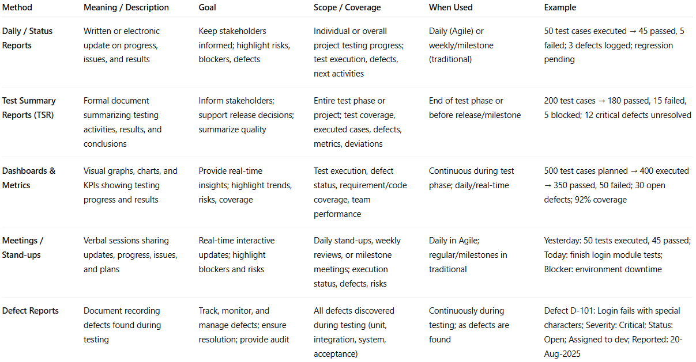

| **Method** | **Meaning / Description** | **Goal** | **Scope / Coverage** | **When Used** | **Example** |
| --- | --- | --- | --- | --- | --- |
| **Daily / Status Reports** | Written or electronic update on progress, issues, and results | Keep stakeholders informed; highlight risks, blockers, defects | Individual or overall project testing progress; test execution, defects, next activities | Daily (Agile) or weekly/milestone (traditional) | 50 test cases executed → 45 passed, 5 failed; 3 defects logged; regression pending |
| **Test Summary Reports (TSR)** | Formal document summarizing testing activities, results, and conclusions | Inform stakeholders; support release decisions; summarize quality | Entire test phase or project; test coverage, executed cases, defects, metrics, deviations | End of test phase or before release/milestone | 200 test cases → 180 passed, 15 failed, 5 blocked; 12 critical defects unresolved |
| **Dashboards & Metrics** | Visual graphs, charts, and KPIs showing testing progress and results | Provide real-time insights; highlight trends, risks, coverage | Test execution, defect status, requirement/code coverage, team performance | Continuous during test phase; daily/real-time | 500 test cases planned → 400 executed → 350 passed, 50 failed; 30 open defects; 92% coverage |
| **Meetings / Stand-ups** | Verbal sessions sharing updates, progress, issues, and plans | Real-time interactive updates; highlight blockers and risks | Daily stand-ups, weekly reviews, or milestone meetings; execution status, defects, risks | Daily in Agile; regular/milestones in traditional | Yesterday: 50 tests executed, 45 passed; Today: finish login module tests; Blocker: environment downtime |
| **Defect Reports** | Document recording defects found during testing | Track, monitor, and manage defects; ensure resolution; provide audit | All defects discovered during testing (unit, integration, system, acceptance) | Continuously during testing; as defects are found | Defect D-101: Login fails with special characters; Severity: Critical; Status: Open; Assigned to dev; Reported: 20-Aug-2025 |

## **📊 Example – Daily Status Report**

**# Source**: **Chatgpt (GPT-5-Standard) at [8/18/2025]**

* Planned test cases: **200**
* Executed test cases: **150**
* Passed: **120**, Failed: **20**, Blocked: **10**
* Defects: **15 open (5 high, 10 medium)**
* Risks: Performance testing delayed due to environment issues
* Next steps: Complete remaining 50 cases + retesting fixed bugs

## **🎯 Audience**

**# Source**: **Chatgpt (GPT-5-Standard) at [8/18/2025]**

* **Project Manager** → progress, risks, schedule impact
* **Developers** → defects, retesting needs
* **Product Owners/Clients** → product readiness, quality status
* **QA Team** → coverage, blocked areas

✅ **In short:** **Communicating the status of testing** = giving clear, timely, and accurate updates on **test progress, defects, coverage, risks, and readiness** so stakeholders can make informed decisions.